**CECS 327**

**Project 5**

**Ansul Chauhan**

**IP:** [34.68.26.10](https://34.68.26.10/)

**Port:** 57471

**PART 1**

Virtual Machine Instance:

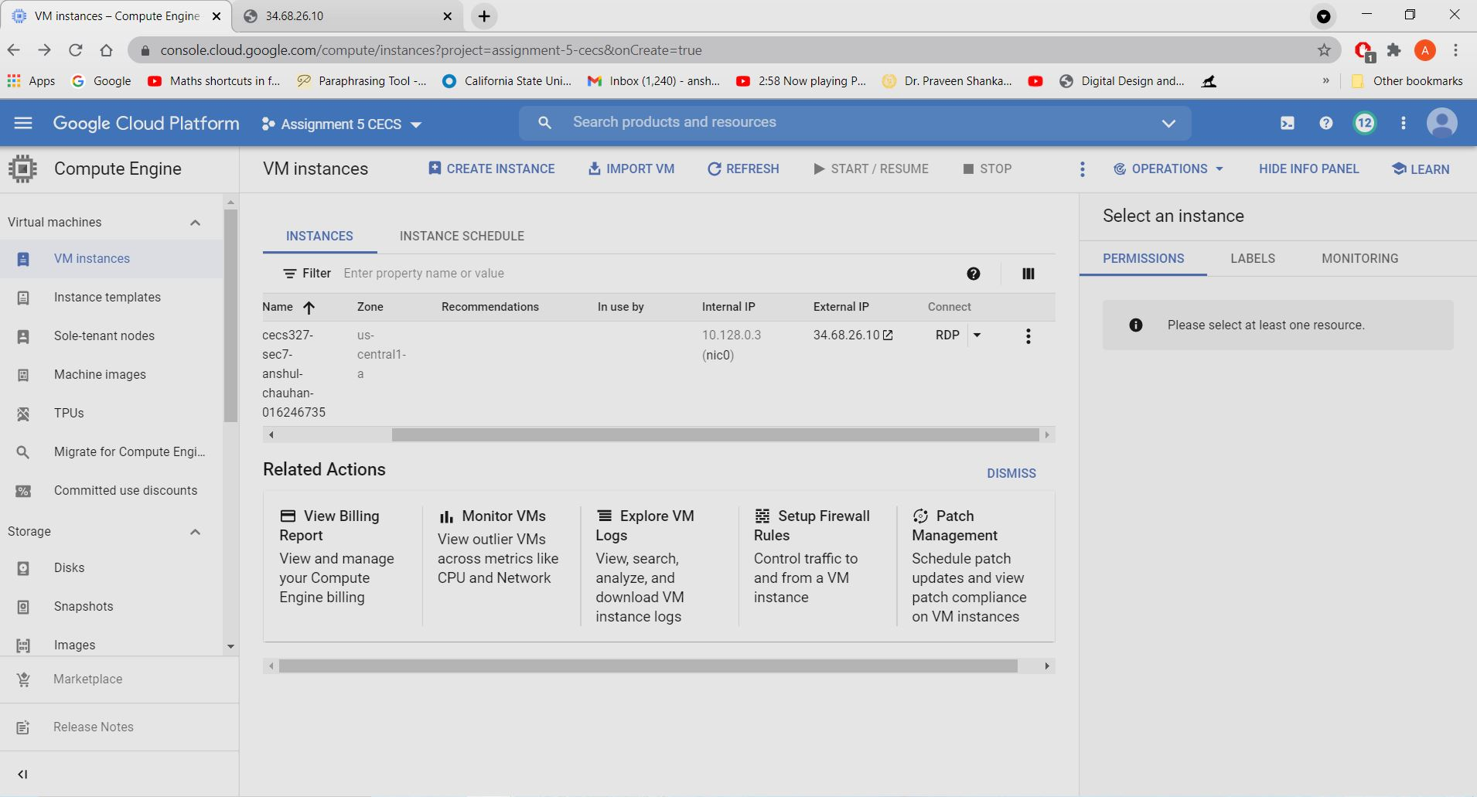

Web Page running on the IP Address:

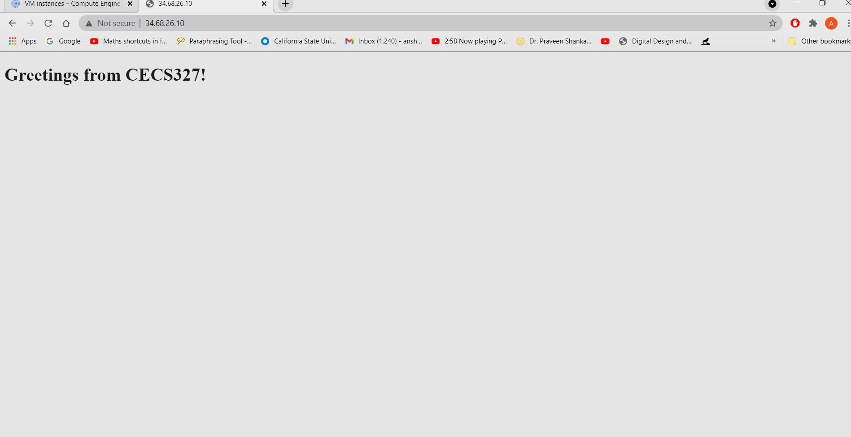

**PART 2**

Client:

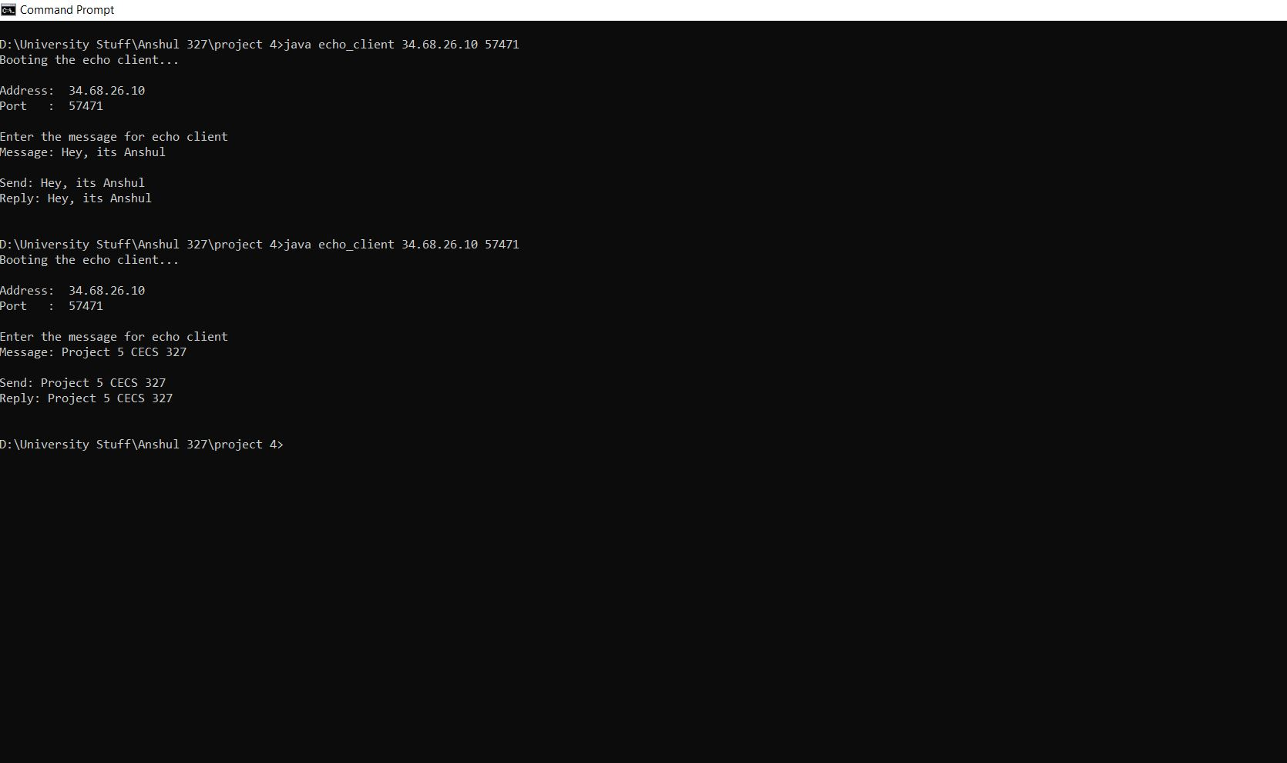

Server:

